**Student Guide for CS4225/CS5425 Coding Assignment**

[1 Overview 1](#_Toc112524090)

[2 Local Environment Setup (Optional) 2](#_Toc112524091)

[2.1 Windows 10 2](#_Toc112524092)

[2.2 Linux 7](#_Toc112524093)

[2.3 MacOS 9](#_Toc112524094)

[3 Login to SoC Clusters 11](#_Toc112524095)

[3.1 Create SoC account 11](#_Toc112524096)

[3.2 Login to SoC Cluster 11](#_Toc112524097)

[4 Configure Hadoop and Spark 15](#_Toc112524098)

[4.1 Modify Environmental Variables 15](#_Toc112524099)

[4.2 Check Environmental Variables 16](#_Toc112524100)

[5 Test Configuration 17](#_Toc112524101)

[5.1 Test Spark 17](#_Toc112524102)

[5.2 Test Hadoop and Submission 18](#_Toc112524103)

[6 VSCode Set-Up 21](#_Toc112524104)

[6.1 Install VSCode and SSH Client 21](#_Toc112524105)

[6.2 Set Up Remote Development 21](#_Toc112524106)

[7 Q&A and Contact 23](#_Toc112524107)

1. Overview

Getting your hands dirty is always an effective way of learning big data systems. It can be a tough and challenging process, but it will also be a fruitful experience. Let’s start from here.

In this student guide, we present the setup that you need to do before Assignments 1 and 2. To minimize the difficulty in installing and configuring Hadoop / Spark under different local environments, we recommend skipping Step 1 and only using the SoC cluster to test your code, as it has Hadoop and Spark already installed for you.

* Step 1 (Optional): You may try to set up a local environment for Hadoop and Spark. This step is not necessary for assignments, in which we will use the SoC cluster as a unified environment.
* Step 2: Test and build your programs in SoC cluster. **We will grade your submission in this environment.** The environment here is similar to cloud environments on public providers. To write your code, you can either edit directly on the clusters using a text editor like vim (<https://en.wikipedia.org/wiki/Vim_(text_editor)>), or write your code locally using an IDE like IntelliJ IDEA (or other IDE / text editor of your choice), then transfer the files to the cluster for testing using scp (see section 5.2 of this guide or <https://linuxize.com/post/how-to-use-scp-command-to-securely-transfer-files/>), or a file transfer software like WinSCP / Cyberduck. This involves the following sub-steps.
  + Step 2.1: Login to SoC Clusters. If you do not have an SoC account, you need to create one. See more details in Section 3 of this guide.
  + Step 2.2: Configure the environments for Hadoop and Spark.
  + Step 2.3: You should be able to run simple programs on Hadoop and Spark. Cheers!

1. Local Environment Setup (Optional)

In case you prefer to test your code locally or for the benefit of future projects, we provide guidelines to help you setup debug environments locally. We recommend IntelliJ IDEA 2020.1 as IDE, on which this section is based. For this assignment, this section is optional and only for reference, as you can also choose to debug and test solely on the cluster. You can also choose other IDEs based on your preference.

To do this, follow the guides in subsection 2.1-2.3 based on your operating system.

* 1. Windows 10

1. **Install Java 11**

Please follow this tutorial to install Java 11 on Windows

<https://java.tutorials24x7.com/blog/how-to-install-java-11-on-windows>. You should also ensure all the environmental variables of Java are set properly (as the tutorial).

1. **Install Hadoop**

Download Hadoop 3.3.0 from  
<https://archive.apache.org/dist/hadoop/common/hadoop-3.3.0/> Unzip to a directory, e.g. C:\\Program Files\hadoop-3.3.0. You do not need to run the installer.

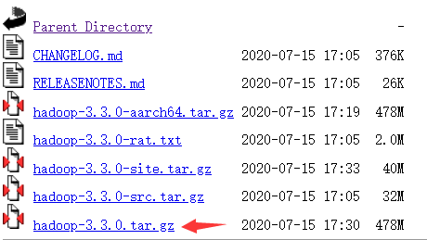

However, this package does not contain some windows native required components. Download these components from <https://github.com/kontext-tech/winutils>,  
then unzip and copy the whole directory hadoop-3.3.0/bin to your installation path of Hadoop , e.g. C:\\Program Files\hadoop-3.3.0. When conflict happens, choose to replace all conflict files Also, copy hadoop-3.3.0/bin/hadoop.dll to C:\Windows\System32.

1. **Configure environment variables for Hadoop**

Open file explorer (by Press Ctrl+E). Right click "This PC", choose "properties". In the popup window, click "Advanced System Settings", then click "Environment Variables". In "system variables", create 2 new system variables by "New…".

HADOOP\_HOME D:\Program Files\hadoop-3.3.0 <Your Path>

HADOOP\_BIN\_PATH %HADOOP\_HOME%\bin



In User variables, edit "PATH" variable by adding %HADOOP\_HOME%\bin and %HADOOP\_HOME%\sbin.

Click "OK", "OK", "OK" to save the changes. It should take effect immediately.

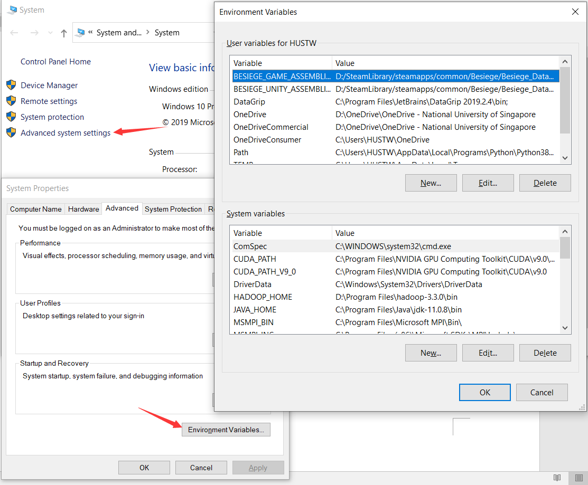

1. **Install IntelliJ IDEA**

Download latest IntelliJ IDEA from  
<https://www.jetbrains.com/idea/download/#section=windows> and install it.

1. **Configure IDEA with Hadoop**

Create Maven project by "File 🡪 New 🡪 Project 🡪 Maven".

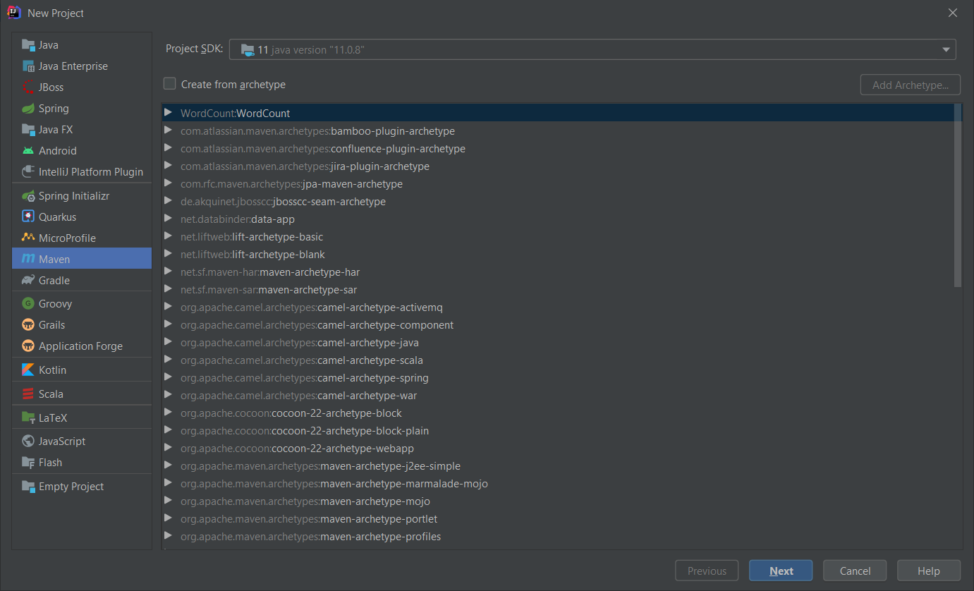

Then, click "Next", enter project WordCount. Click "Artifact Coordinates", enter information like the below figure.

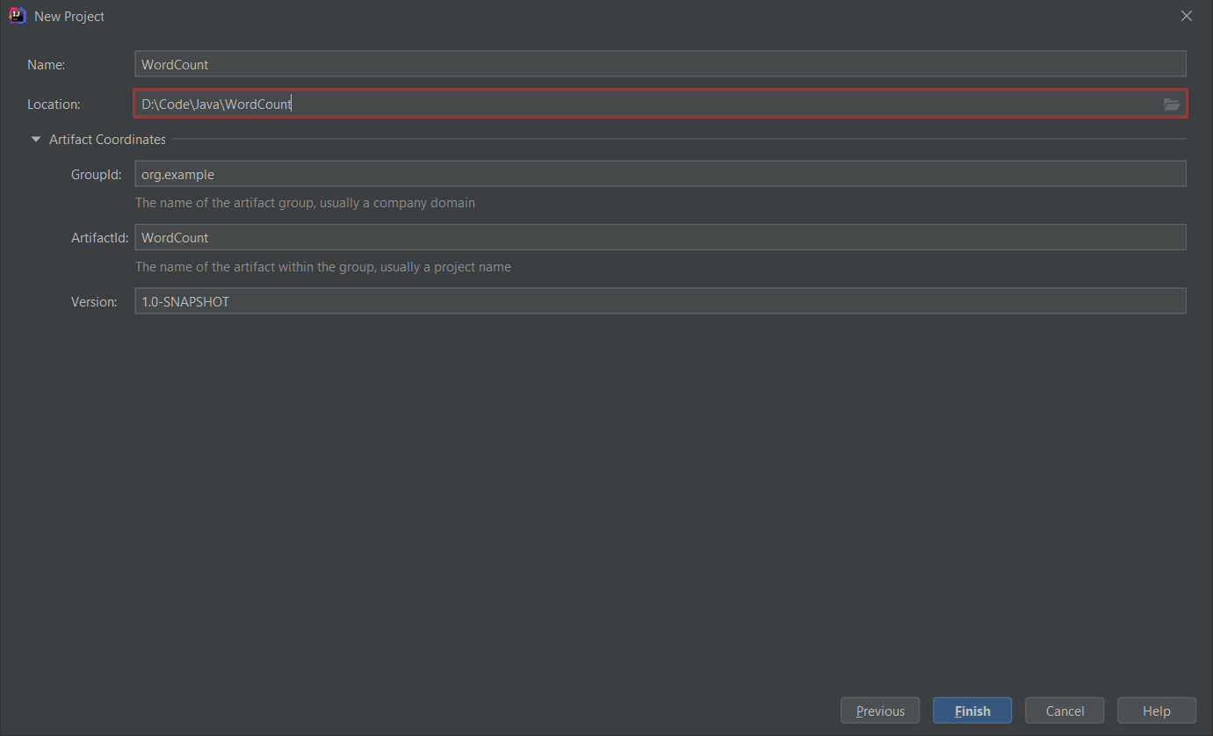

Click Finish to create the project. Your project structure should look like this.

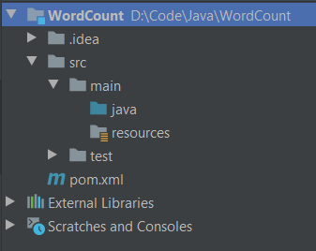

To prevent an error, add the following lines to pom.xml.

<properties>

<maven.compiler.source>1.8</maven.compiler.source>

<maven.compiler.target>1.8</maven.compiler.target>

</properties>

Then reload all maven projects

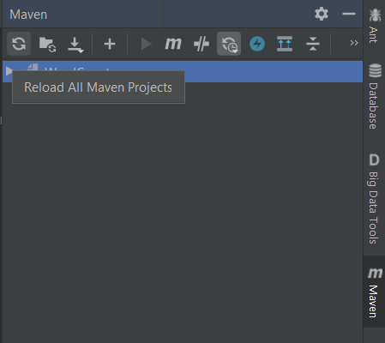

Then add Hadoop dependencies by File 🡪 Project Structure 🡪 Modules 🡪 Dependencies. Click "+ 🡪 JARS or directories"

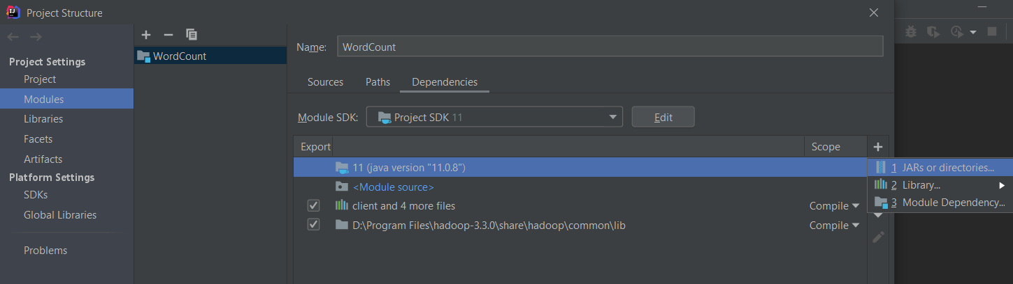

Add the following directories as dependencies.

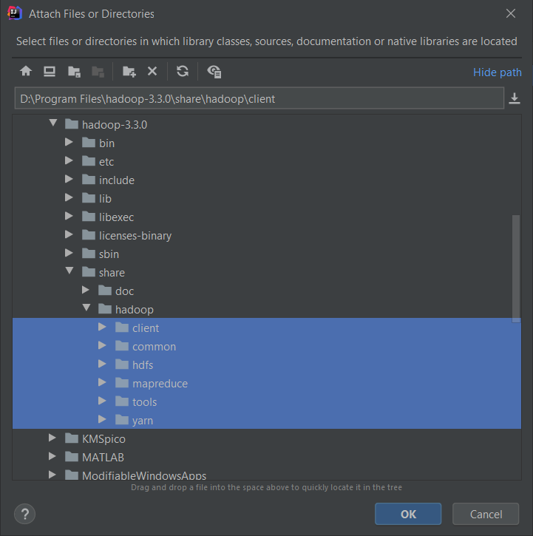 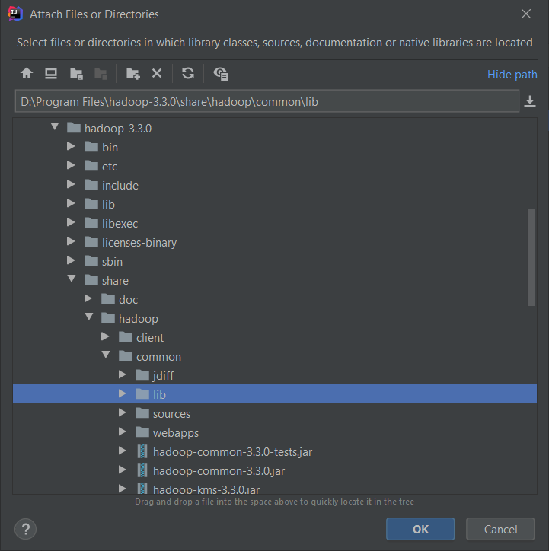

After that, the dependencies should look like this. Then click "OK".

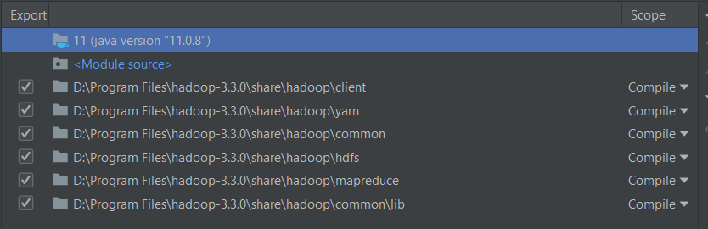

Create a java class file WordCount.java like below

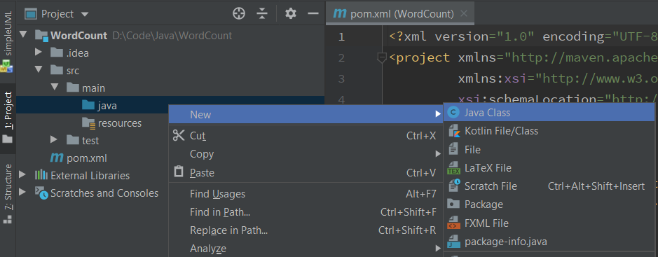

Download assign0\_hadoop\_test from Luminus or from the cluster (see subsection 5.2). Find example codes WordCount.java in the package. Copy the content of WordCount.java in that file. Then create a directory input and two text files in the directory file0.txt and file1.txt. Their contents are as below.

(input/file0.txt)

Hello World Bye World

(input/file1.txt)

Hello Hadoop Goodbye Hadoop

The directory structure should look like this now.

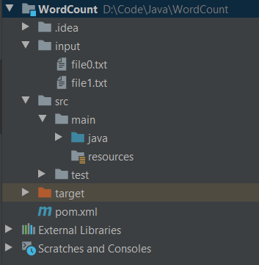

Then click "Add configurations" on right top. In the popup window, click "+ 🡪 Application". Configure as below.

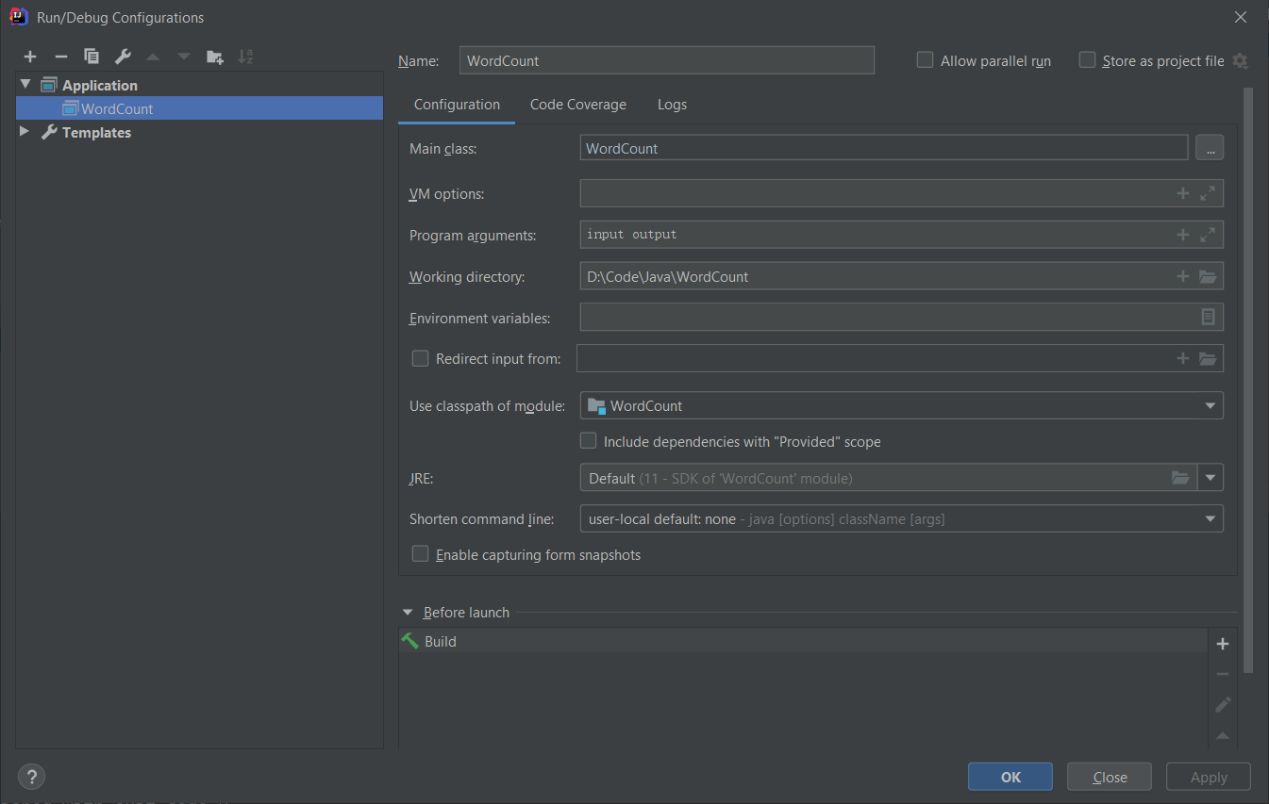

Then click OK. Click the green triangular button "run" to run the program. After it finishes, the project structure will contain a new folder output.

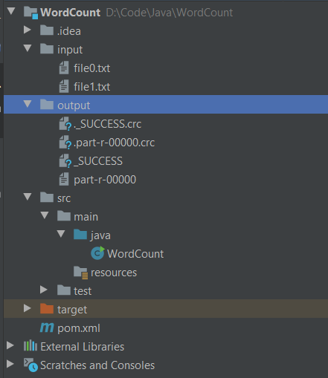

output/part-r-00000 contains the result of word count.

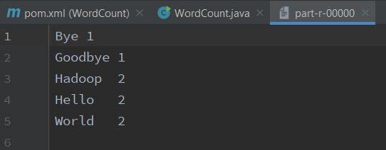

You can also click to debug button to debug your program. IntelliJ IDEA is a very powerful IDE. Enjoy exploring.

* 1. Linux

1. **Install Java 11**

There are a lot of tutorials about installing Java 11, you can choose one based on your Linux distribution.

* Ubuntu: <http://ubuntuhandbook.org/index.php/2018/11/how-to-install-oracle-java-11-in-ubuntu-18-04-18-10/>
* CentOS: <https://linuxhint.com/install_oracle_jdk11_centos7/>
* Arch Linux: <https://wiki.archlinux.org/index.php/Java>
* Fedora: <https://www.tecmint.com/install-java-in-fedora/>

After installation, check your java version by following command

$ java –version

openjdk version "11" 2018-09-25

OpenJDK Runtime Environment 18.9 (build 11+28)

OpenJDK 64-Bit Server VM 18.9 (build 11+28, mixed mode)

You should ensure the JDK version is 11. The implementation could be either OpenJDK or Oracle JDK. Meanwhile, remember the path where your install java, e.g. /usr/lib/java. Add an environmental variable JAVA\_HOME by

$ echo 'export JAVA\_HOME=/usr/lib/java' >> ~/.bash\_profile

$ source ~/.bash\_profile

You can check if successful by

$ echo $JAVA\_HOME

/usr/lib/java

Note: Do not simply copy the commands. You need to check your installation path first.

1. **Install Hadoop**

Download Hadoop 3.3.0

$ wget https://archive.apache.org/dist/hadoop/common/hadoop-3.3.0/hadoop-3.3.0.tar.gz

$ tar xzvf hadoop-3.3.0.tar.gz

Configure java path for Hadoop: recall the path where you install java in a), e.g. /usr/lib/java. Edit hadoop-3.3.0/etc/hadoop/hadoop-env.sh. Find export JAVA\_HOME=, and change this line to export JAVA\_HOME=/usr/bin/java.

Note: Do not simply copy the commands. You need to check your installation path first.

1. **Install IntelliJ IDEA**

Download latest IntelliJ IDEA from (Ultimate is free for NUS students, Community is enough for this module)

<https://www.jetbrains.com/idea/download/#section=linux>

Unzip the file

$ tar xzvf ideaIC-2020.2.tar.gz

run IDEA by

$ cd ideaIC-2020.2

$ bin/idea.sh

1. **Configure IDEA with Hadoop**

This part is exactly the same as that on Windows 10 in Section 2.1 e) Configure IDEA with Hadoop. Please refer to that subsection.

* 1. MacOS

1. **Install Java 11**

Follow the guide of Linux in section 2.2 a).

1. **Install Hadoop**

You can install via brew. Simply run

brew install Hadoop

Make sure your installed version is 3.3.0. You can also install as the Linux guide in section 2.2 b).

Configure java path for Hadoop, recall the path where you install java in a), e.g. /usr/lib/java. Edit <hadoop-installation-path>/etc/hadoop/hadoop-env.sh. Find export JAVA\_HOME=, change this line to export JAVA\_HOME=<Java-installation-path>.

Note: Do not simply copy the commands. You need to check your installation path first.

1. **Install IntelliJ IDEA**

Download latest IntelliJ IDEA from (Ultimate is free for NUS students, Community is enough for this module)

<https://www.jetbrains.com/idea/download/#section=mac>

1. **Configure IntelliJ IDEA**

This part is exactly the same as that on Windows 10 in Section 2.1

1. **Configure IDEA with Hadoop**

Please refer to that subsection.

1. Login to SoC Clusters

This is required for all students who take this module since all the assignments will be run, submitted and graded on SoC clusters.

* 1. Create SoC account

All the students from SoC and students who take SoC modules can register a SoC account. Registration and enabling clusters are done on **‘mySoC’**. For more details, please refer to the following link: <https://dochub.comp.nus.edu.sg/cf/guides/compute-cluster/enable-disable-access> .

* 1. Login to SoC Cluster

If you are connecting to SoC network, you can connect to xcnc<24-31>.comp.nus.edu.sg directly via ssh. (For load balancing purposes, try to choose one of these randomly, or one that is less occupied). For example, if your SoC ID is “studentA”, then you can login to xcnc24 as follows:

$ ssh studentA@xcnc24.comp.nus.edu.sg

You have two ways to connect to SoC cluster: through a jump server or through NUS VPN. For Windows and Mac users, using VPN is recommended. For Linux users, please connect via jump server.

1. **Jump Server Solution**

Suppose your soc ID is "studentA”, open a terminal, type   
$ ssh studentA@sunfire.comp.nus.edu.sg  
and return. Then input your soc account password, and then you should successfully connect to the jump server.

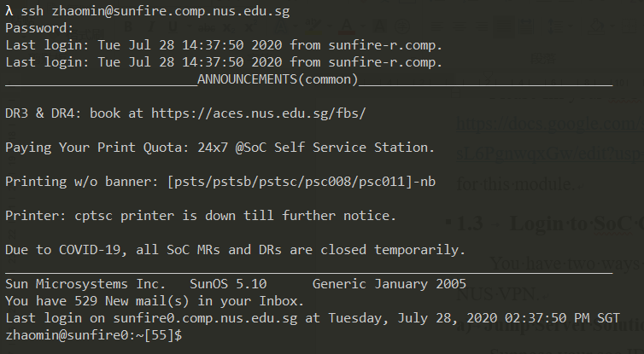

Then type ssh xcnc24 (or any server xcnc24-31) on sunfire and return, then type your SoC account password. You will connect to one machine in SoC clusters.

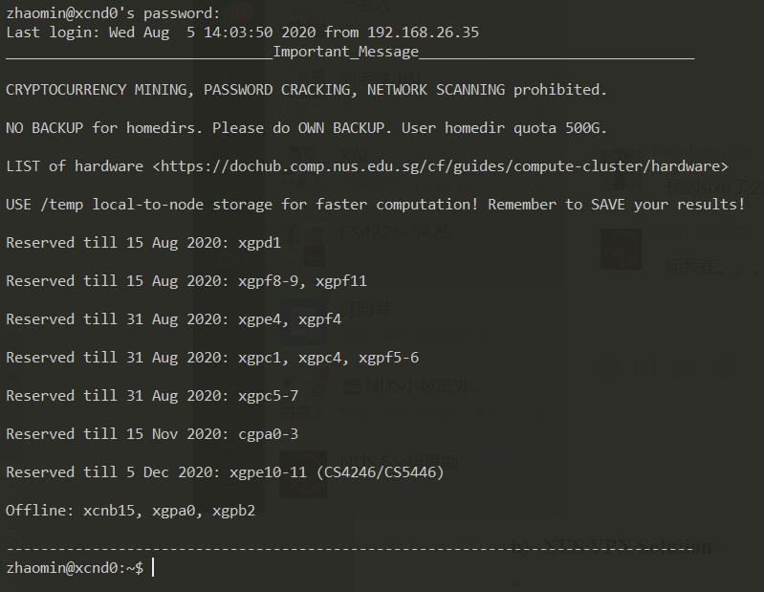

1. **NUS VPN Solution**

For Windows and Mac users, please download FortiClient VPN from the following link: <https://webvpn.comp.nus.edu.sg/sslvpn/portal.html#/> . Then install and run FortiClient VPN on your laptop. After launching FortiClient, you should observe

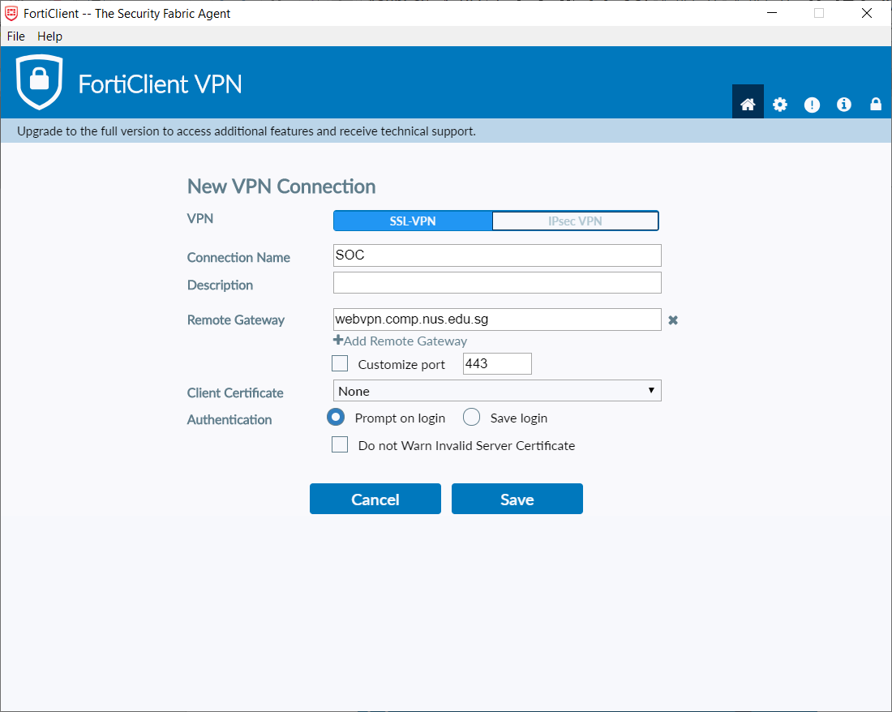

Fill in the information as above, then click "Save", you should see

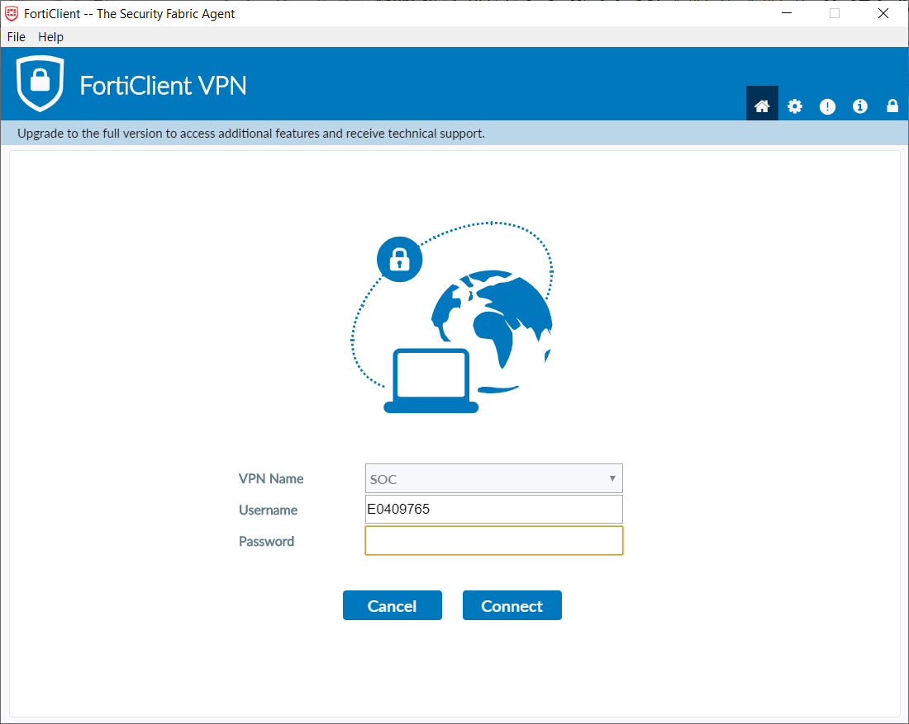

Choose "VPN Name” as "SOC”, fill in your NUSNET ID and password, click "connect”. After a few seconds, you should see the following information, which indicates successful connection.

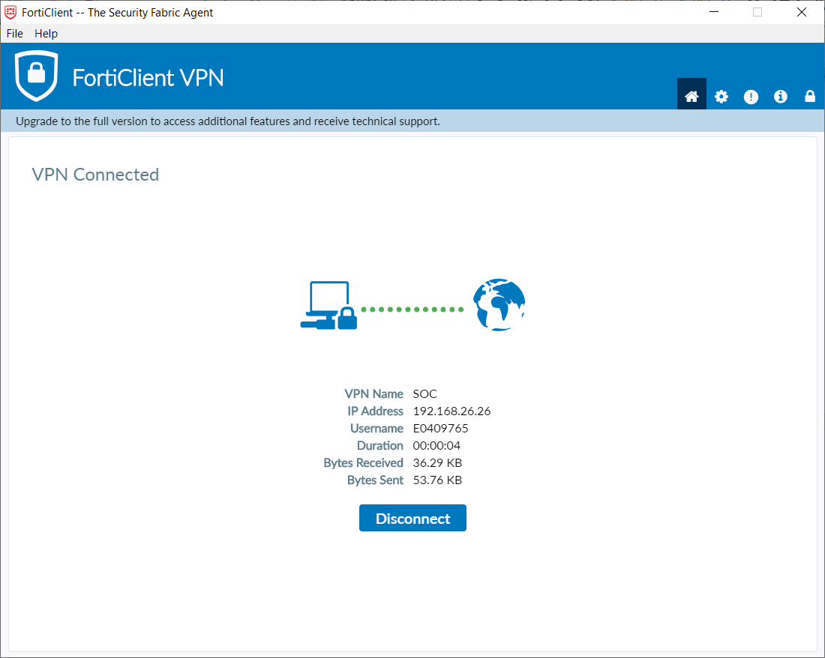

After successfully connecting, suppose your soc account id is "studentA”, open terminal and type ssh studentA@xcnc24.comp.nus.edu.sg. Then type your soc account password, then you will connect to one machine in SoC clusters.



1. Configure Hadoop and Spark

Hadoop and spark have been already installed on the clusters. All you need to do is to run it. All the following procedures are done on clusters, e.g. xcnc24.

* 1. Modify Environmental Variables

First open ~/.bash\_profile by vim

$ vim ~/.bash\_profile

Press i on keyboard to enter insert mode. Copy the following contents and paste at the end of the file. (Important: make sure you enter insert mode before pasting; otherwise, some characters will be missing when you paste).

BASE\_DIR=/home/b/bhooi/cs4225

export JAVA\_HOME=$BASE\_DIR/jdk-11.0.12

export HADOOP\_HOME=/home/b/bhooi/cs4225/hadoop-3.3.0

export SPARK\_HOME=$BASE\_DIR/spark-3.0.0-bin-hadoop3.2

export PATH=$PATH:$HADOOP\_HOME/bin

export PATH=$PATH:$SPARK\_HOME/bin

export HADOOP\_CONF\_DIR=$HADOOP\_HOME/etc/hadoop

export HADOOP\_MAPRED\_HOME=$HADOOP\_HOME

export HADOOP\_COMMON\_HOME=$HADOOP\_HOME

export HADOOP\_HDFS\_HOME=$HADOOP\_HOME

export YARN\_HOME=$HADOOP\_HOME

export HADOOP\_CLASSPATH=$JAVA\_HOME/lib/tools.jar

export PATH=$JAVA\_HOME/bin:$HADOOP\_HOME/bin:$PATH

You should see as follows.

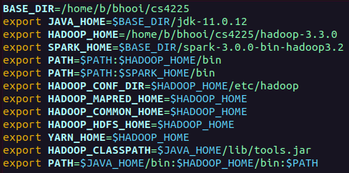

Then press "ESC" on keyboard to exit insert mode. Type :wq and return to save and exit vim. After saving, run the following command in terminal.

$ source ~/.bash\_profile

PS: By default, the system may source "~/.bashrc" instead, so you may need to repeat the above command to setup your configuration each time you login.

* 1. Check Environmental Variables

To check if the environmental variables are correctly set, simply run the following command.

$ echo $HADOOP\_HOME && echo $SPARK\_HOME

If you get the following results, that means your configuration is successful.

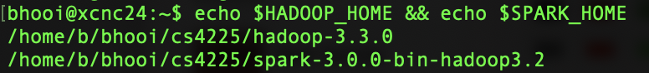

1. Test Configuration
   1. Test Spark

To test the availability of spark, simply run an example program of spark by

spark-submit --deploy-mode client --class org.apache.spark.examples.SparkPi $SPARK\_HOME/examples/jars/spark-examples\_2.12-3.0.0.jar

This program will estimate the value of . After some calculation (few seconds to a minute), it should output the similar results to the following one.

PS: The program will output a different estimated value each time. You can check at <https://github.com/apache/spark/blob/master/examples/src/main/python/pi.py> for reference.

<Many lines of text here… please scroll all the way to the bottom>

…

Pi is roughly 3.1350556752783763

2020-08-04 20:55:12,042 INFO server.AbstractConnector: Stopped Spark@31f0ddb1{HTTP/1.1,[http/1.1]}{0.0.0.0:4040}

2020-08-04 20:55:12,049 INFO ui.SparkUI: Stopped Spark web UI at http://xcnd0.comp.nus.edu.sg:4040 2020-08-04 20:55:12,055 INFO cluster.YarnClientSchedulerBackend: Interrupting monitor thread

2020-08-04 20:55:12,083 INFO cluster.YarnClientSchedulerBackend: Shutting down all executors

2020-08-04 20:55:12,084 INFO cluster.YarnSchedulerBackend$YarnDriverEndpoint: Asking each executor to shut down

2020-08-04 20:55:12,091 INFO cluster.YarnClientSchedulerBackend: YARN client scheduler backend Stopped

2020-08-04 20:55:12,108 INFO spark.MapOutputTrackerMasterEndpoint: MapOutputTrackerMasterEndpoint stopped!

2020-08-04 20:55:12,135 INFO memory.MemoryStore: MemoryStore cleared

2020-08-04 20:55:12,135 INFO storage.BlockManager: BlockManager stopped

2020-08-04 20:55:12,145 INFO storage.BlockManagerMaster: BlockManagerMaster stopped

2020-08-04 20:55:12,149 INFO scheduler.OutputCommitCoordinator$OutputCommitCoordinatorEndpoint: OutputCommitCoordinator stopped!

2020-08-04 20:55:12,212 INFO spark.SparkContext: Successfully stopped SparkContext

2020-08-04 20:55:12,219 INFO util.ShutdownHookManager: Shutdown hook called

2020-08-04 20:55:12,221 INFO util.ShutdownHookManager: Deleting directory /tmp/spark-1dc8df74-cc87-465d-b4fd-3ff6f54b00ef

2020-08-04 20:55:12,226 INFO util.ShutdownHookManager: Deleting directory /tmp/spark-4fbed1cb-afe1-431f-b9d4-94279a6266b9

* 1. Test Hadoop and Submission

In this subsection, we will go through the procedure of “a mock test” using assignment 0 (a simple test program, whose code is already fully written) for a real assignment, including downloading files, writing codes, running program and submitting. All the operations in this subsection are performed on the clusters.

1. **Download Assignment Files**

All required packages will be stored in /home/b/bhooi/cs4225/cs4225-materials on SoC clusters. You can download these files by navigating to where you want to copy them to (e.g. your home directory), then using the following command:

$ cp -r /home/b/bhooi/cs4225/cs4225-materials/assign0\_hadoop\_test .

Then you should find a new folder assign0\_hadoop\_test in your home directory.

Simply check by

$ ls assign0\_hadoop\_test



Alternatively, if you want to first write your codes locally, you can download assignment files from LumiNUS and upload to the server after you finished. The upload can be done by scp. With your (e.g. stuA's) NUS VPN connected, enter the folder which contains the directory you want to upload, and run this command on your own laptop

$ scp -r assign0\_hadoop\_test stuA@xcnc24.comp.nus.edu.sg:~

After finishing copying, you will find a new folder assign0\_hadoop\_test under your home directory on xcnc24. If you are using Linux and cannot connect to xcnc24, you can upload your submission to sunfire first and then upload to xcnc24 by scp. To learn more about scp, please refer to: <https://haydenjames.io/linux-securely-copy-files-using-scp/>.

1. **Write your code**

For assignment 0, the code in WordCount.java is already written for you.

1. **Compile and Run Your Codes**

Enter that folder and call the scripts to automatically compile and run

$ cd ~/assign0\_hadoop\_test

$ ./compile\_run

The script will compile and run WordCount.java, which counts the words in file01.txt and file02.txt. After a short calculation, you will see the following result.

Job finished. Print results.

Bye 1

Goodbye 1

Hadoop 2

Hello 2

World 2

Test passed.

The script will automatically compare your result to the answer. If the output is "Test Passed", that means your result is correct on the given dataset. Otherwise, it means that your result is incorrect and you need to double check your codes.

1. **Submit**

If you think you have finished the assignment, you can submit your codes. First upload the directory to the clusters by scp if it is now on your laptop. (see step a.)

$ ./submit

Again note that./submitis only valid when running on clusters. Do NOT run on your own laptop**.** Then follow the guide of the script to input your matriculation number (not your email address; it should be starting with A) and return. When you see the following lines, it means your submission has been accepted.

C:\Users\HUSTW\AppData\Roaming\Tencent\Users\929387970\TIM\WinTemp\RichOle\Y5KINJYT_Z5TI(N`EOY}DSB.png

You are allowed to submit multiple times before the due date; your last submission will be graded. After due time, the submission folder will be locked and no more submission will be accepted. Do remember Do NOT modify any filename in the folderor the scripts may fail. If submission script reports any error, that means your submission is unsuccessful. Please inform the TAs as soon as possible.

Although Hadoop has load balancing itself, you are still recommended to choose a machine with less CPU consumption; i.e. replace xcnc24 with xcnc25, …, xcnc31, e.g. selecting one at random. You can check CPU and memory consumption by htop. In case you face issues with the clusters for some reason (e.g. if the clusters go down or becomes excessively slow near the deadline), please email the TAs who will try to handle it (or extend the deadline if necessary).

Finally, once you have successfully tested using assignment 0, you can start on assignment 1. Similar to assignment 0, you can copy the files by navigating to the place you want to copy it to, then entering:

$ cp -r /home/b/bhooi/cs4225/cs4225-materials/assign1\_common\_words .

Then write your code in TopkCommonWords.java , and similar to assignment 0, use the compile\_run and submit scripts in the same directory to run and submit your code respectively.

1. VSCode Set-Up

This part is optional but it can help to make it more convenient for you to write and test code directly in the remote development environment. In this section, we will briefly demonstrate how to set up VSCode to access and work on the SoC cluster.

* 1. Install VSCode and SSH Client

[Visual Studio Code](https://code.visualstudio.com/) (VSCode) is a lightweight but powerful source code editor which runs on your desktop and is available for Windows, macOS and Linux. The Remote Development of VSCode allows you to write and test code directly in the remote development environment in a more convenient way.

To begin with, please go to the official website to download and install VSCode following the SETUP guides:

1. **Windows**: <https://code.visualstudio.com/docs/setup/windows>
2. **Linux**: <https://code.visualstudio.com/docs/setup/linux>
3. **MacOS**: <https://code.visualstudio.com/docs/setup/mac>

Then install an [OpenSSH compatible SSH client](https://code.visualstudio.com/docs/remote/troubleshooting#_installing-a-supported-ssh-client) (PuTTY is not supported) as follows:

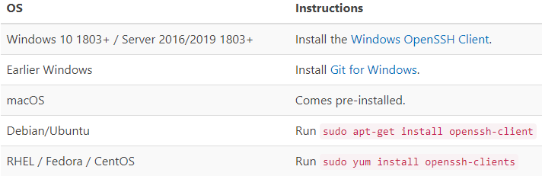

VSCode will look for the ssh command in the PATH. Failing that, on Windows it will attempt to find ssh.exe in the default Git for Windows install path. You can also specifically tell VS Code where to find the SSH client by adding the remote.SSH.path property to settings.json.

* 1. Set Up Remote Development

After installation, click the Extensions  in the column on the left of the VSCode window. Then search and install the extension Remote Development as follows.

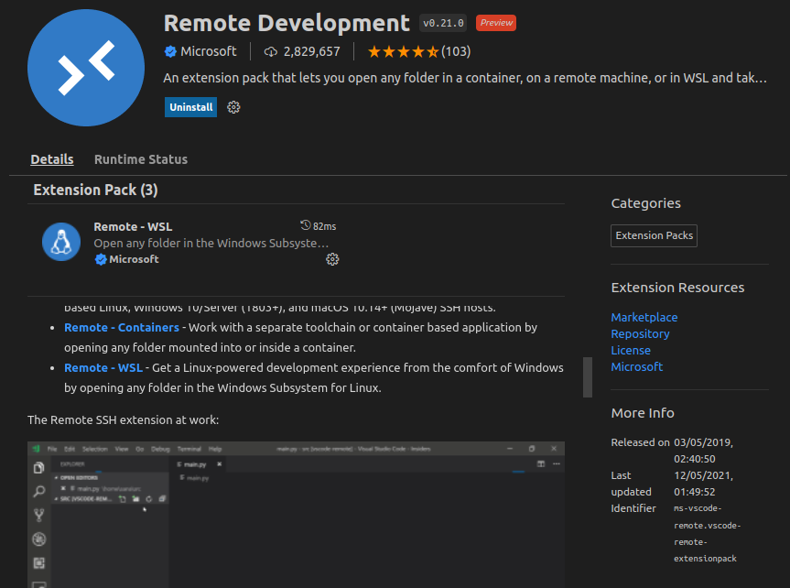

Now there will be an additional item Remote Explorer  in the column on the left, just below the Extensions .

Click the item and choose SSH Targets. Then click the plus and type in the ssh command to connect to the SoC cluster (also remember to connect to SoC VPN in advance).

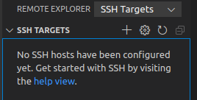 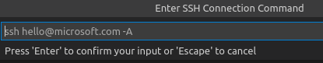

After typing in and selecting the ssh configuration file, the ssh command will be added to the list of SSH targets. To connect, click the Connect to Host in New Window item to the right of the hostname, and enter password.

 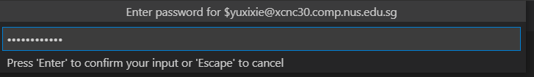

After that, VSCode will open a new window which is connected to remote.

To edit the code files, you can click the Explorer item in the right column and Open Folder to the path of the file(s). Please notice that you’ll need to enter password again here but the folder path will also be added to the list of SSH targets.

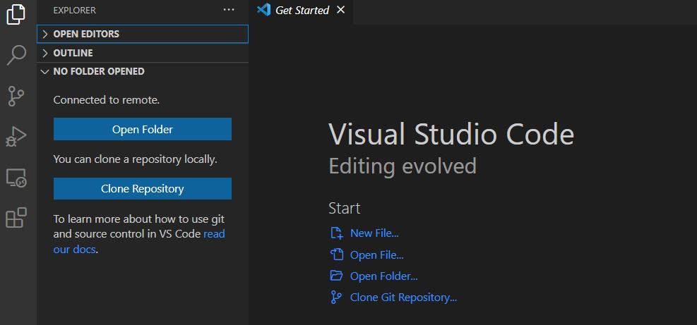

To run the compile\_run and submit scripts, you can click New Terminal under the Terminal on top of the window to start a terminal for entering commands in the shell.

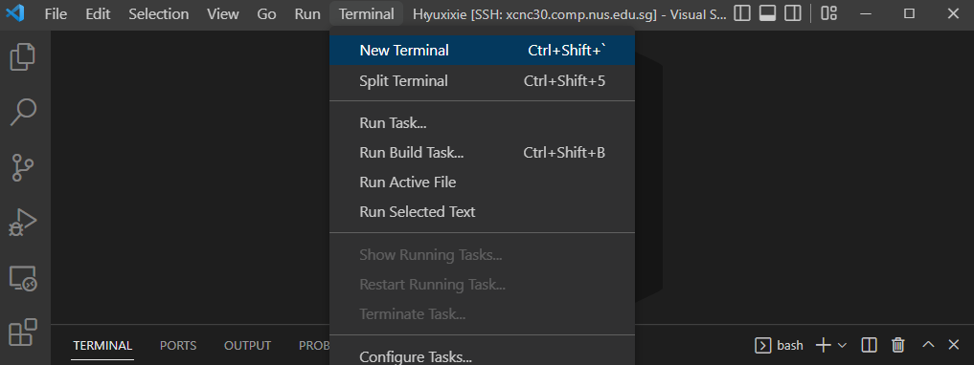

Now you can directly edit and run the code on the server just like you do in your local environment.

1. Q&A and Contact

If you have any questions, you are encouraged to submit them to the forum in LumiNUS. Otherwise, for Coding Assignment 1, please contact Xie Yuxi, [xieyuxi@u.nus.edu](mailto:xieyuxi@u.nus.edu) ; for Coding Assignment 2, please contact Fyonn Oh, [e0325987@u.nus.edu](mailto:e0325987@u.nus.edu) . Please note that, we may anonymize your question, and post the question as well as the answer to the forum (for sharing).

**For your reference:** we have included some frequent Q&A from previous semesters. You can use it as reference (but note it may contain outdated information).

**Q: Failed to ssh to xcnc24: Connection closed by (IP)**

Reason: SoC clusters is not enabled by default. Solution: Enable SoC clusters at [mySoC](https://mysoc.nus.edu.sg/~myacct/services.cgi)

**Q: -bash: ./compile\_run: Permission Denied**

Reason: You need to grant execute permission to compile\_run. Solution: Grant execute permission by chmod +x compile\_run

**Q: Fine on local machine, "ArrayIndexOutOfBoundsException" or "NullPointerException", or other unexpected output on clusters**

Reason: One possible reason is that static class variables are used in Hadoop, which will not be shared across machines. Solution: Avoid using static variables.

**Q: Fine on local machine, got "Wrong Answer" or "FileNotFoundException: stopwords.txt"**

Reason: Load stopwords.txt directly from the system. This works fine on local machine since there is no HDFS. But on clusters, files in HDFS cannot be loaded in this way. Solution: Load stopwords.txt by Java HDFS API (see the compile\_run script given in the assignment package)

**Q: Fine on local machine, got "ClassNotFoundException for 'Pair'" on clusters**

Reason: Not known yet. Solution: Use another alternative data structure instead of Pair. Or, implement a custom Pair yourself.

**Q: I got a warning "xxx". But my code is runnable and produces the correct output (Test Passed). Why?**Reason: N/A

Solution: Submit and move on to the next task.